DAY-2 Jaishri.S

(20.03.2022)

Today ,I have attach background colour to the text view.

Using res->drawable->bg_login.xml

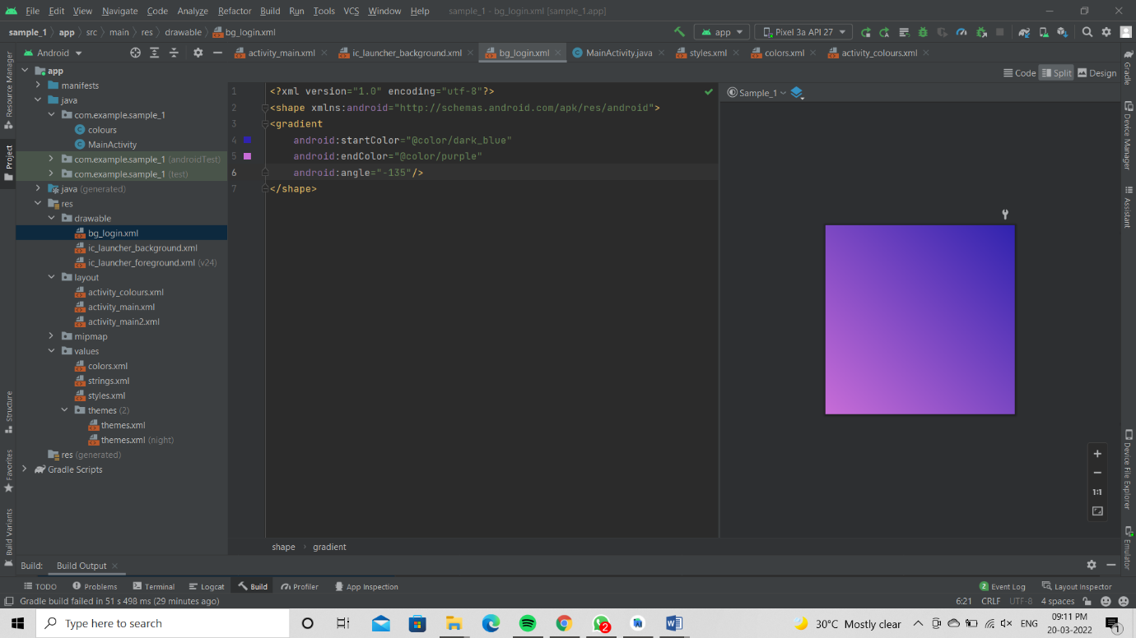

I have learned how to attach the multi colour background for text view .

I got more experience in android studio than yesterday.